**Method of updating the sensor setting on the HWM Data Gate V2.58 Platform**

**Introduction**

This document is an instruction for changing the logging rate and data uploading rate of the sensors at Tsing Yi Q leak.

**Login Account**

An account with ‘power user’ level is required to login to the HWM Data Gate V 2.58. The following account is created for LSGI:

User name: ansonyik

Password: Yik@2021

**Steps of updating the setting**

1. Login to the HWM Data gate v2.58 by the above login information
2. Select the related sensors

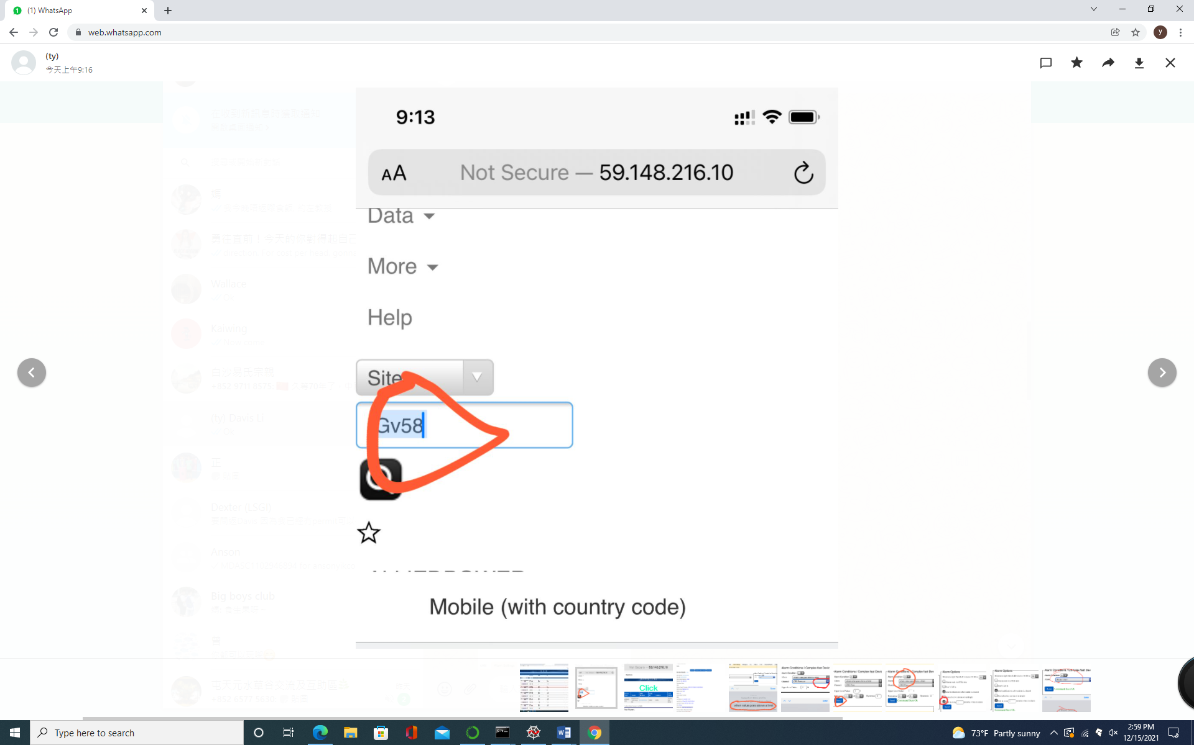

1. Click into the row of the sensors

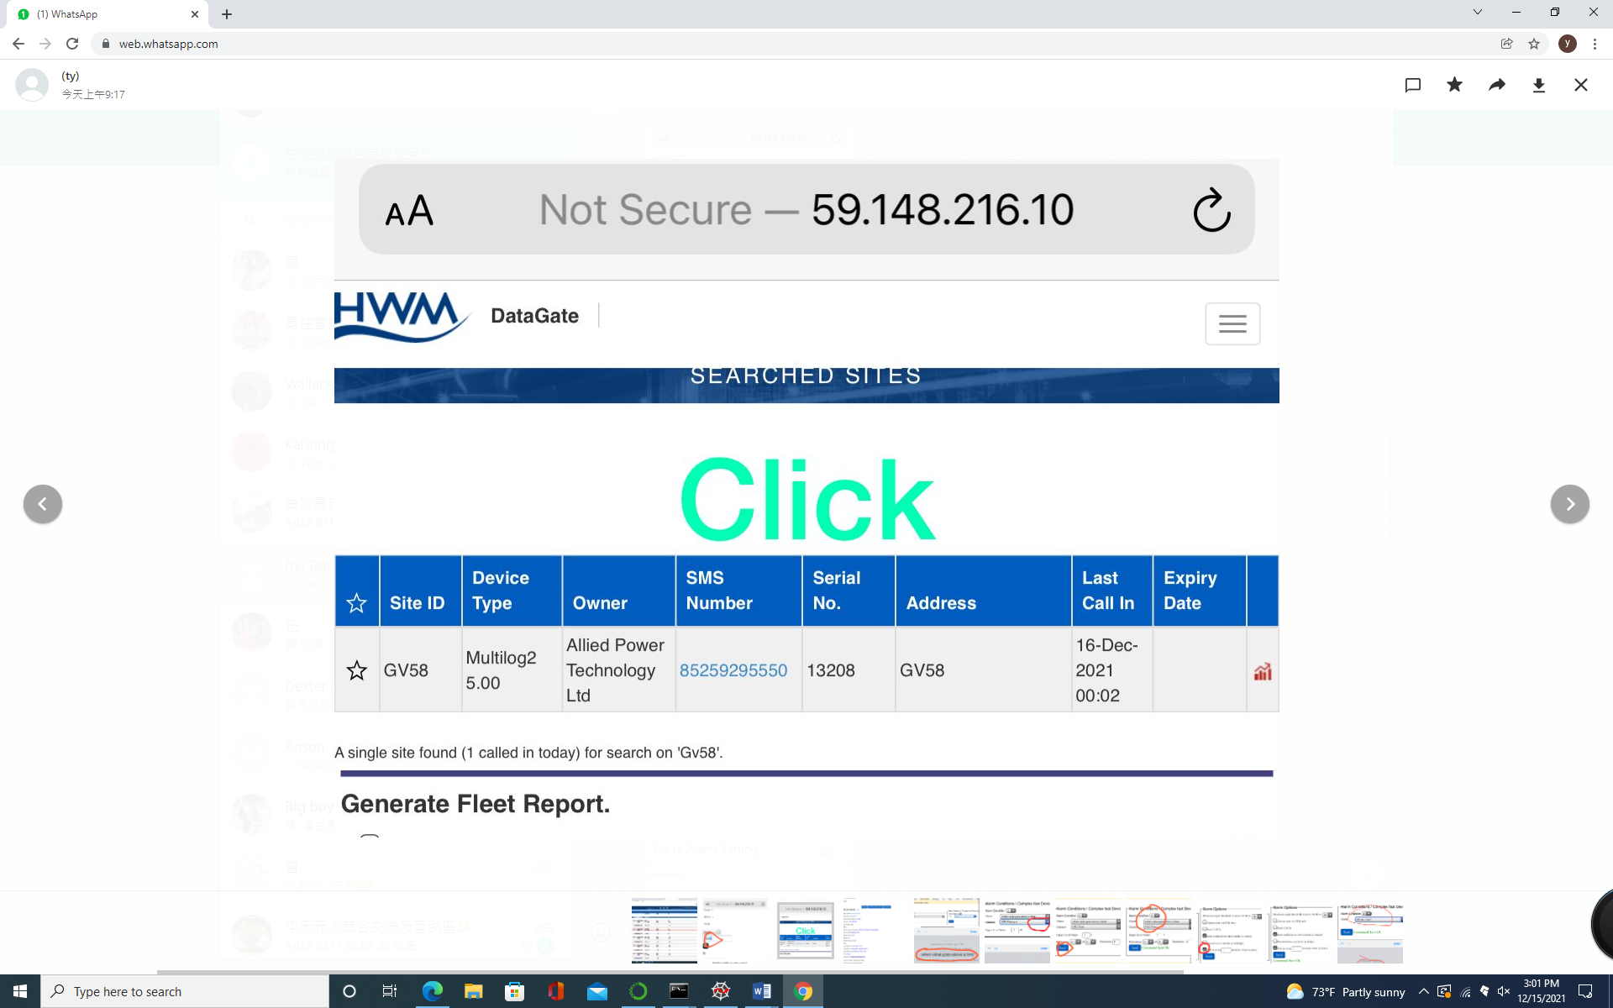

1. Select the ‘alarm setting’ tab

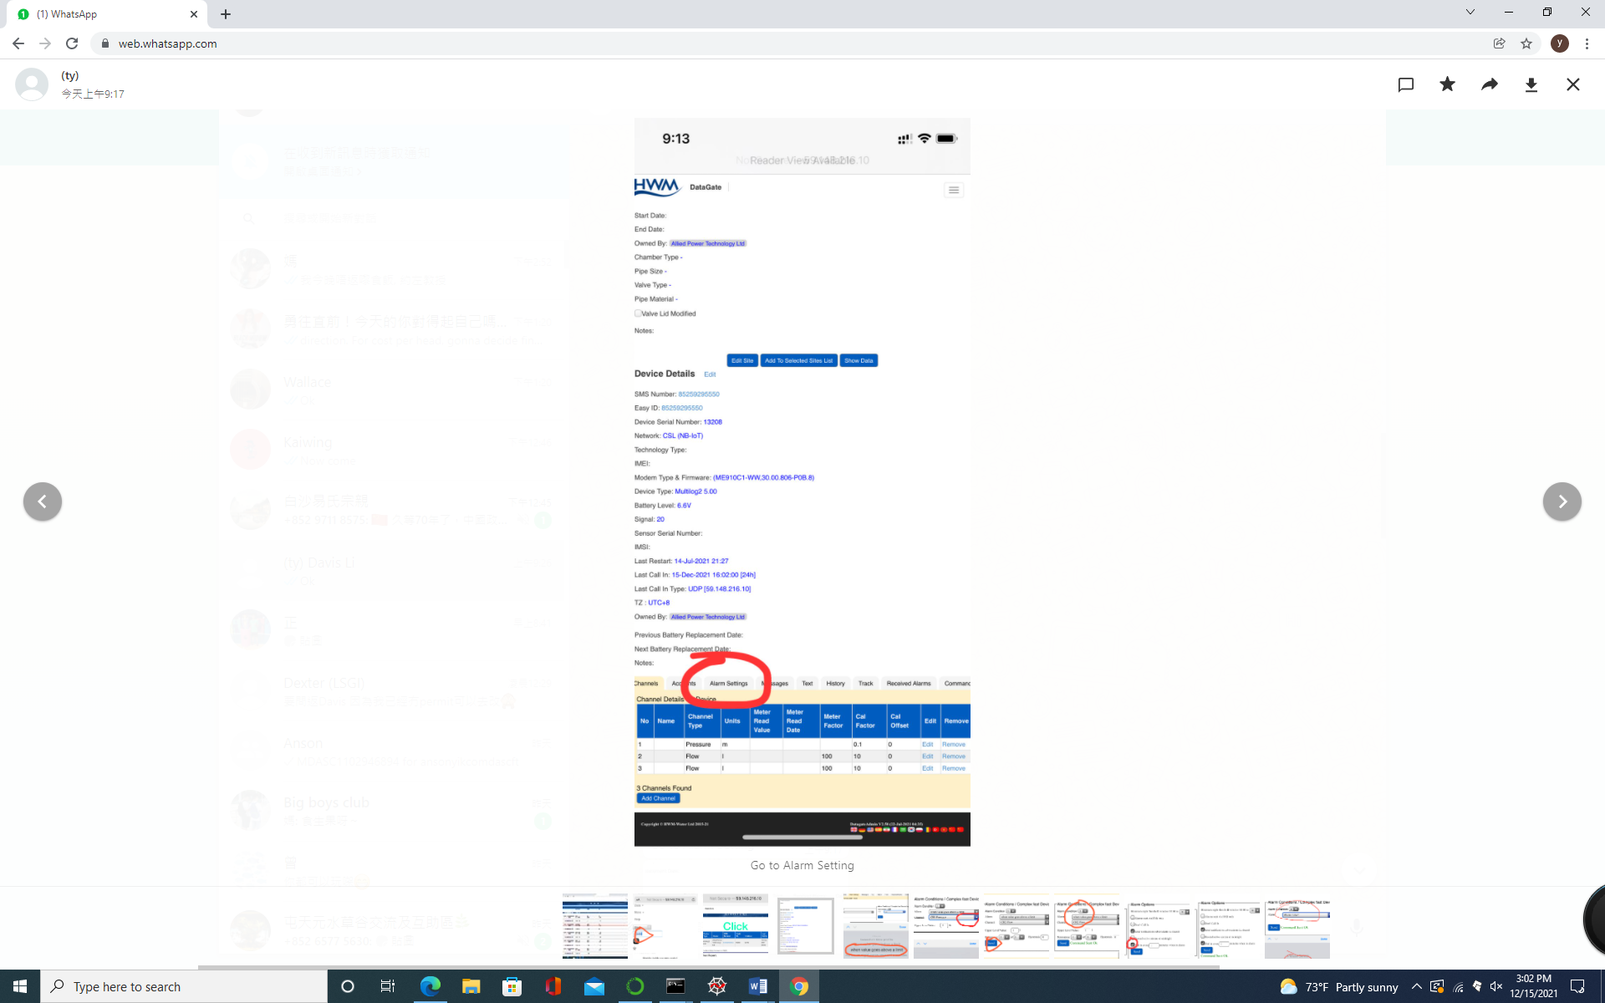

1. Set the alarm condition to ‘when value goes above a limit’

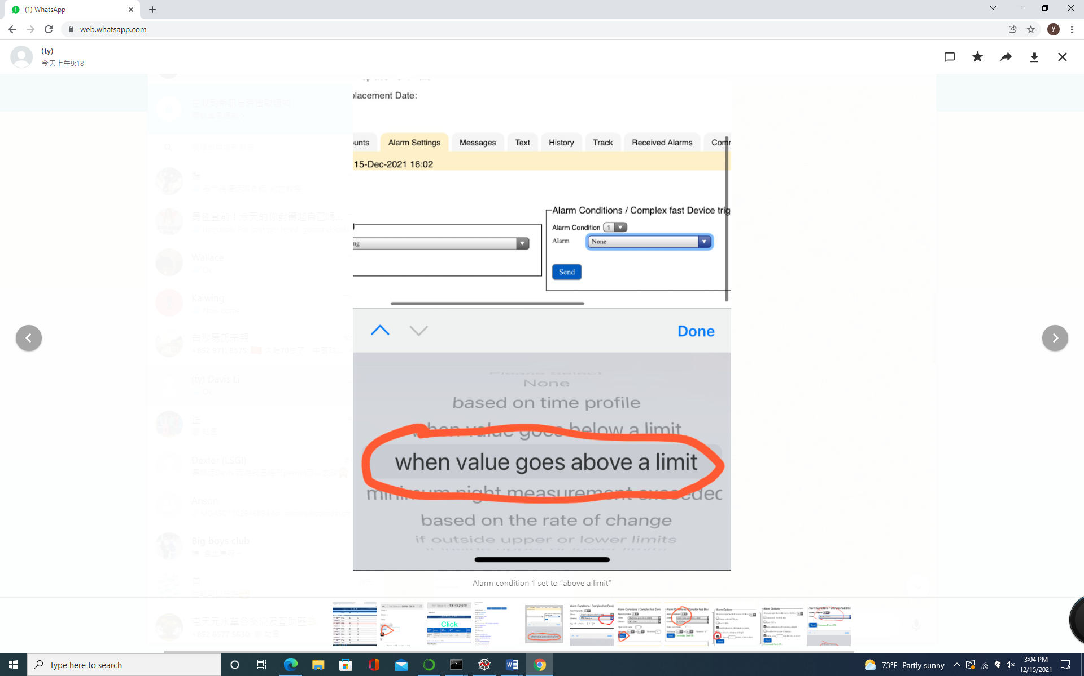

1. Select the channel of the flow rate (CH2 Flow)

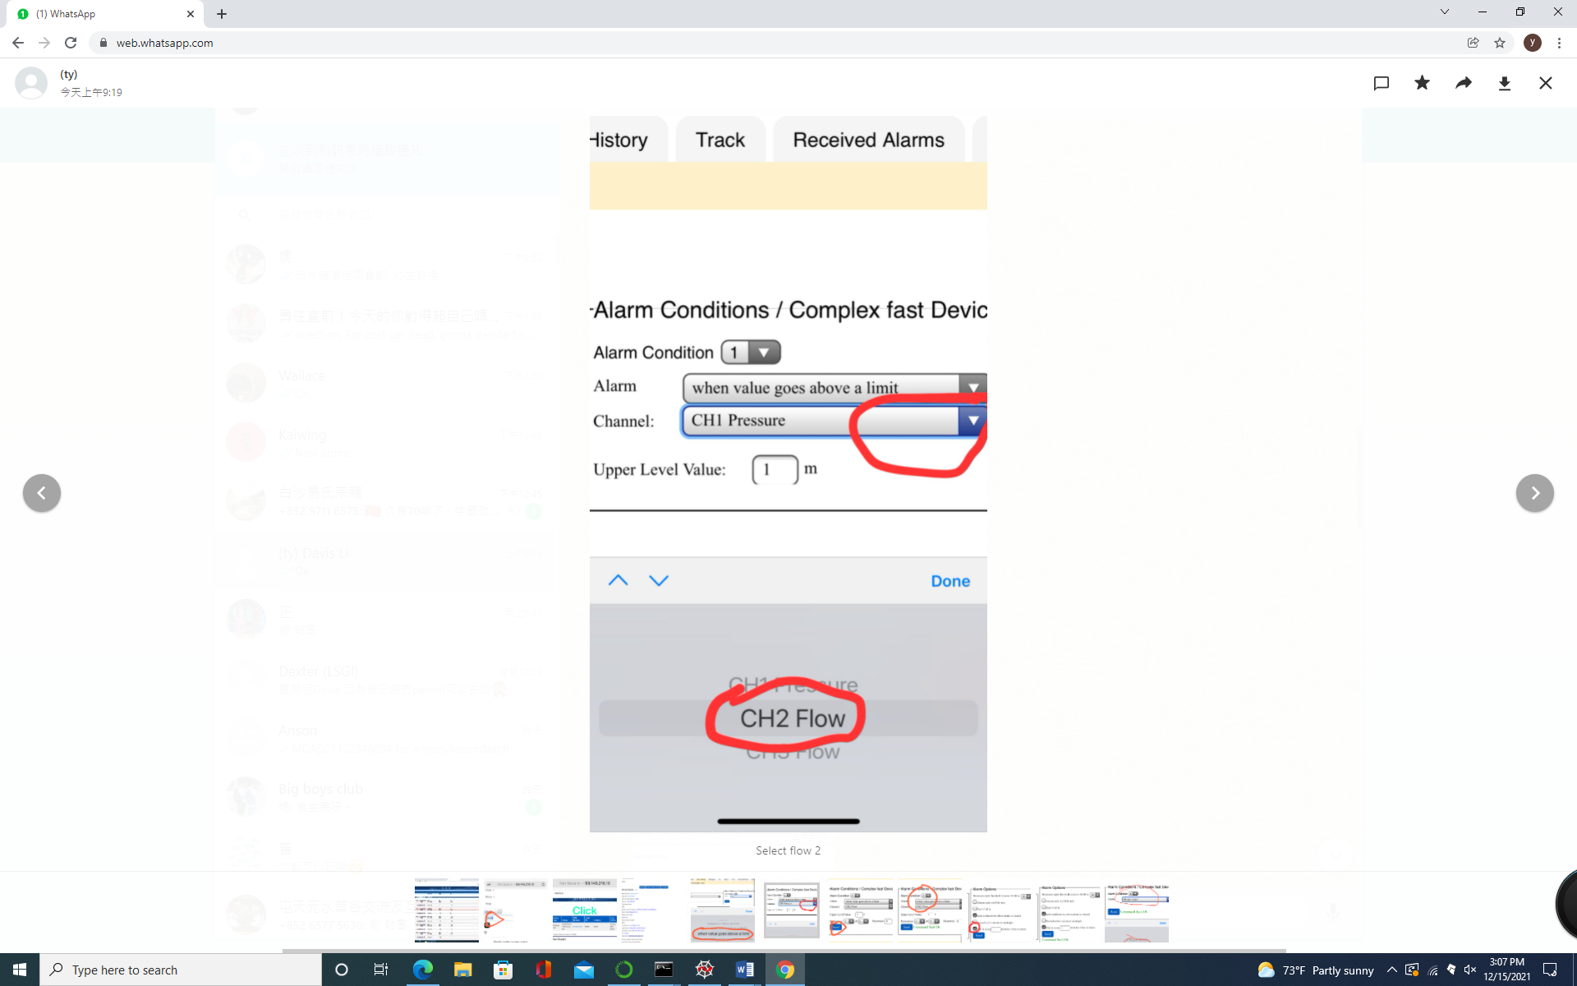

1. Click ‘send’

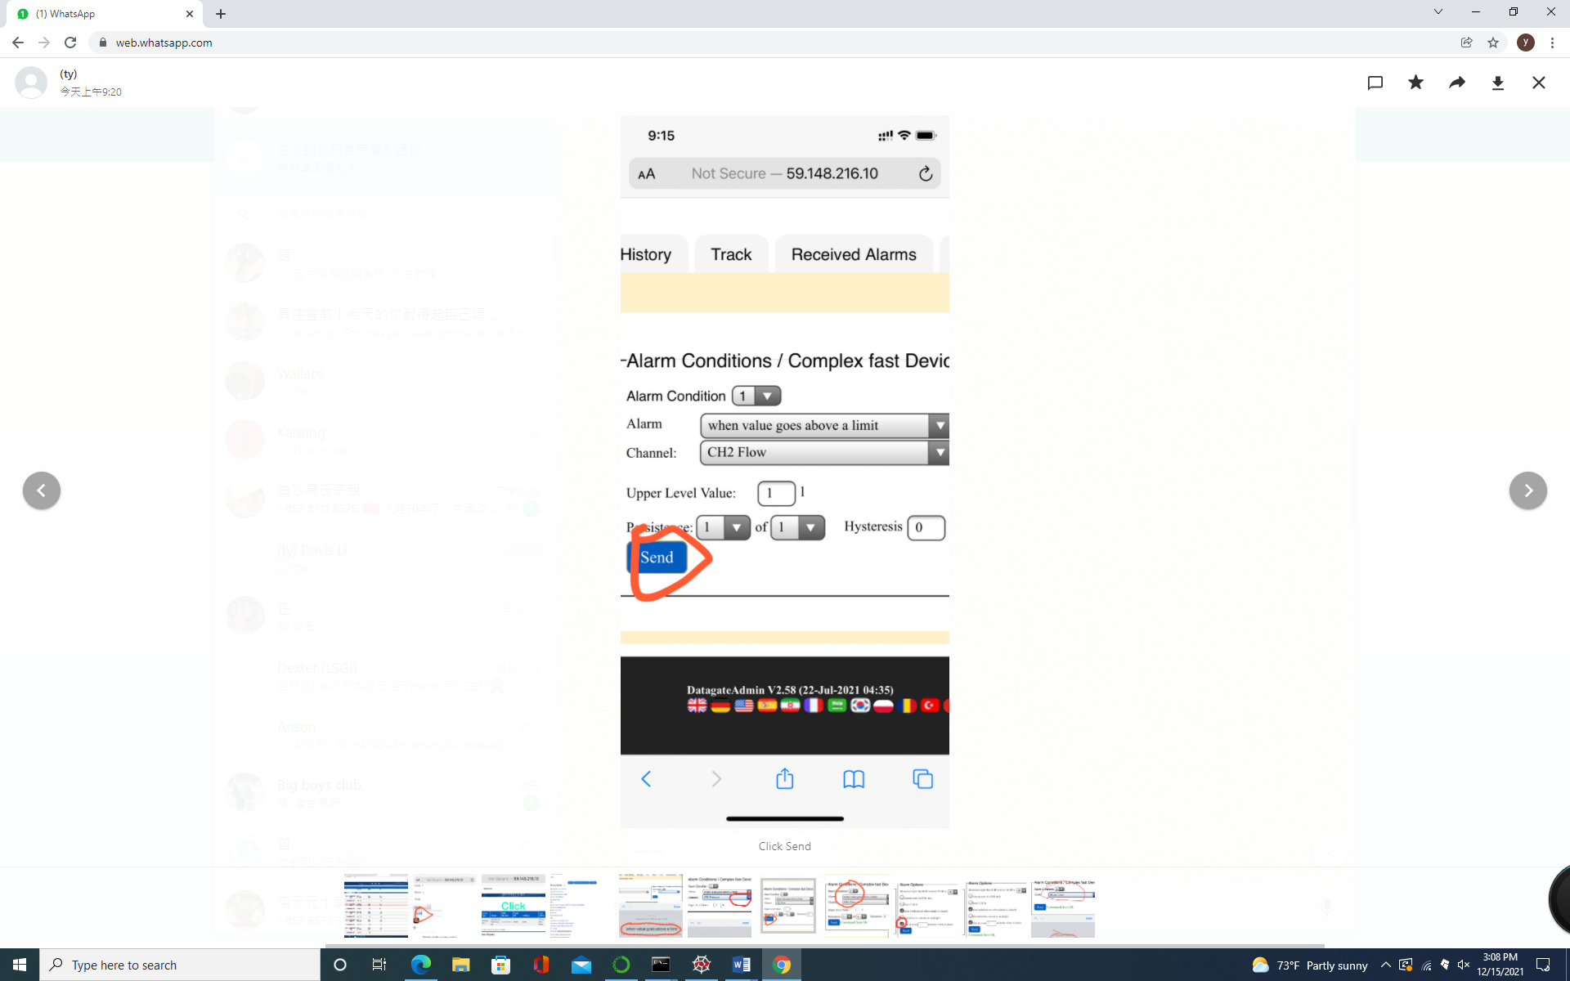

1. After seeing command sent ok, repeat by selecting Alarm condition 2, this time set CH3 Flow

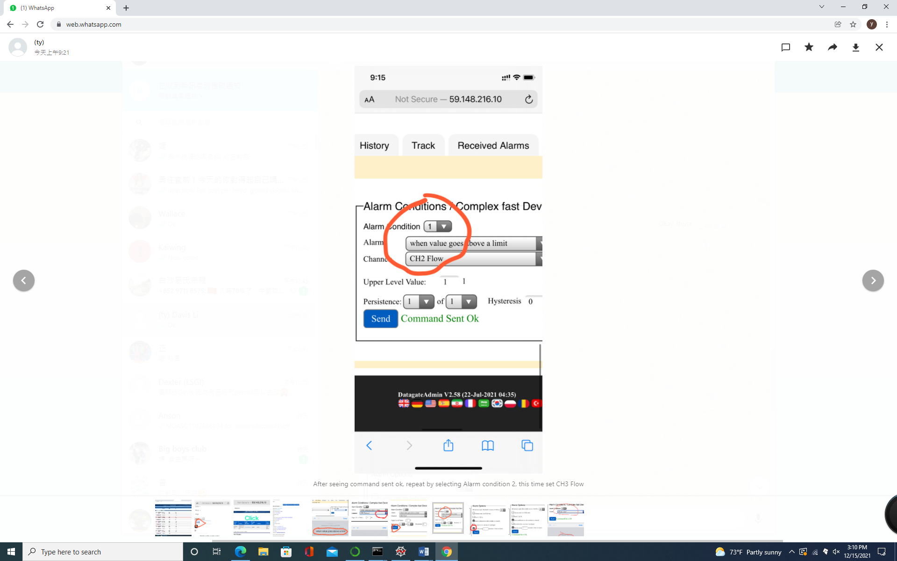

1. Tick call in every 1min in the alarm option fields

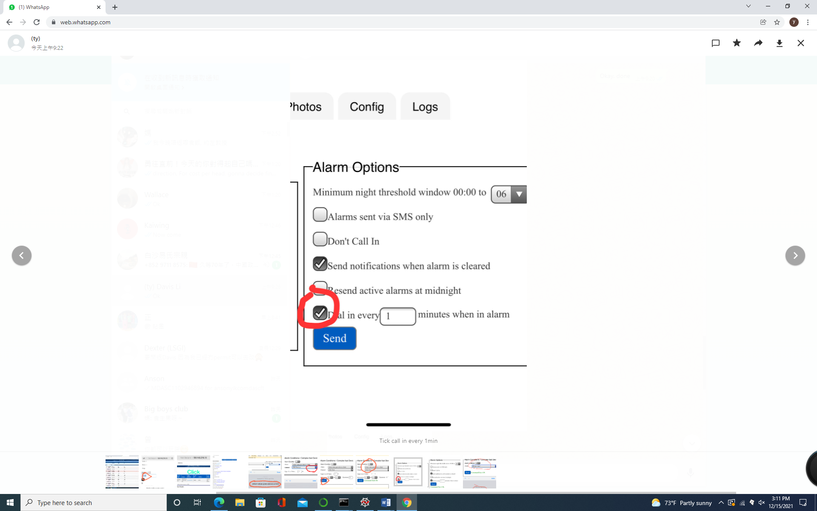

1. Then click send

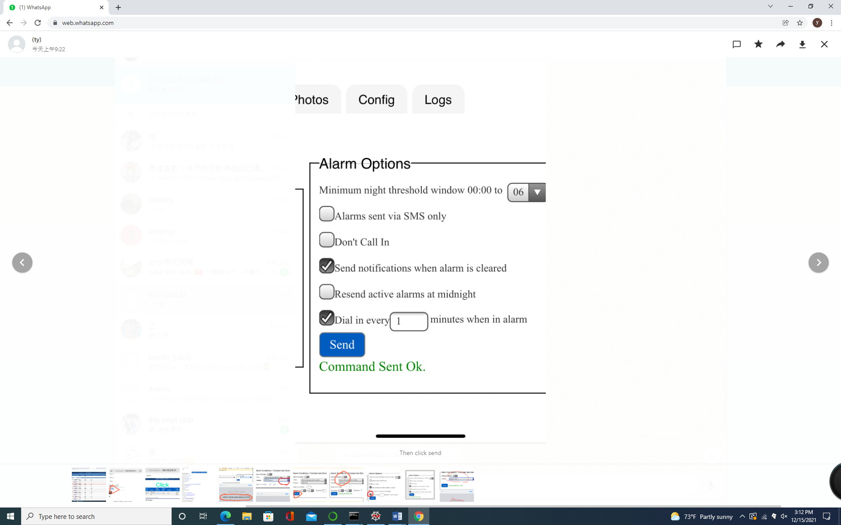

1. Turn the Alarm back to ‘None’ after finishing the test/ another usage of the sensors in order to save energy.

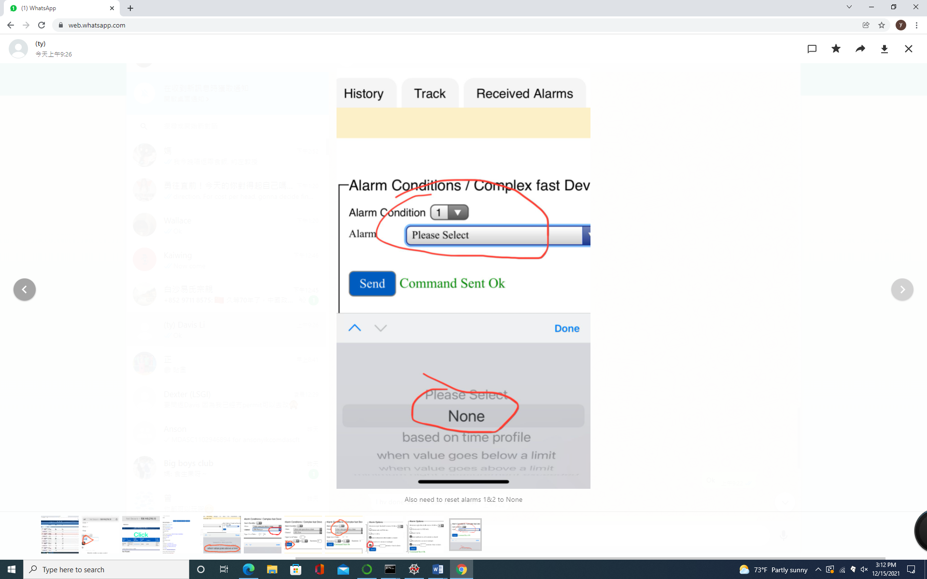

**Time of sending commands**

The commands should be changed on or before Wednesday. Since the sensors will call-in at Wed morning.